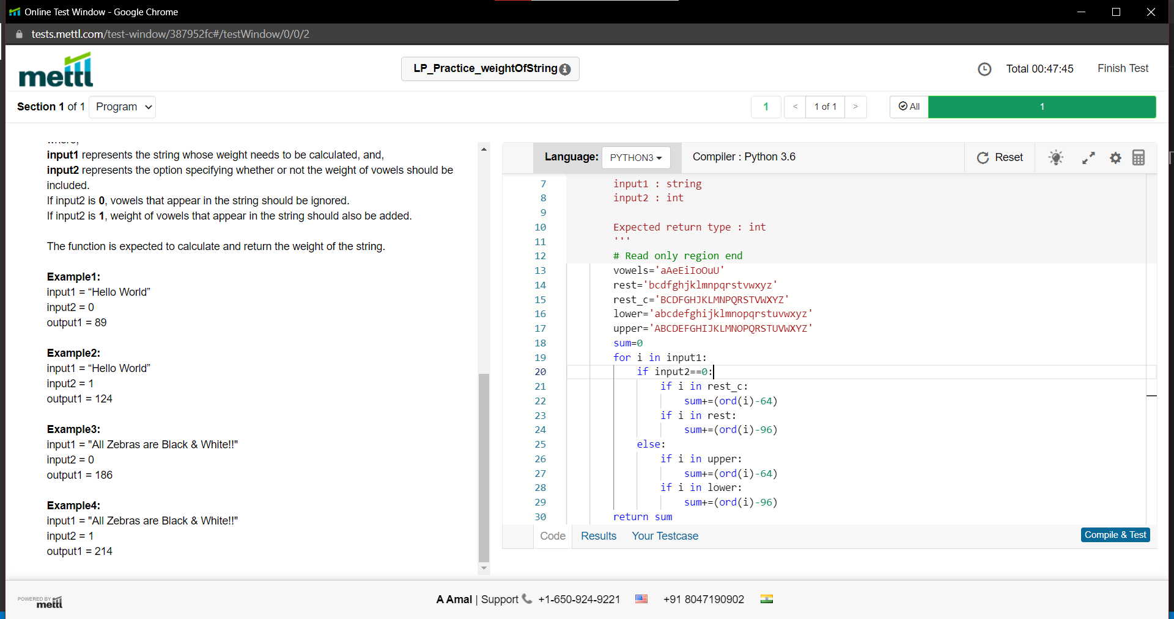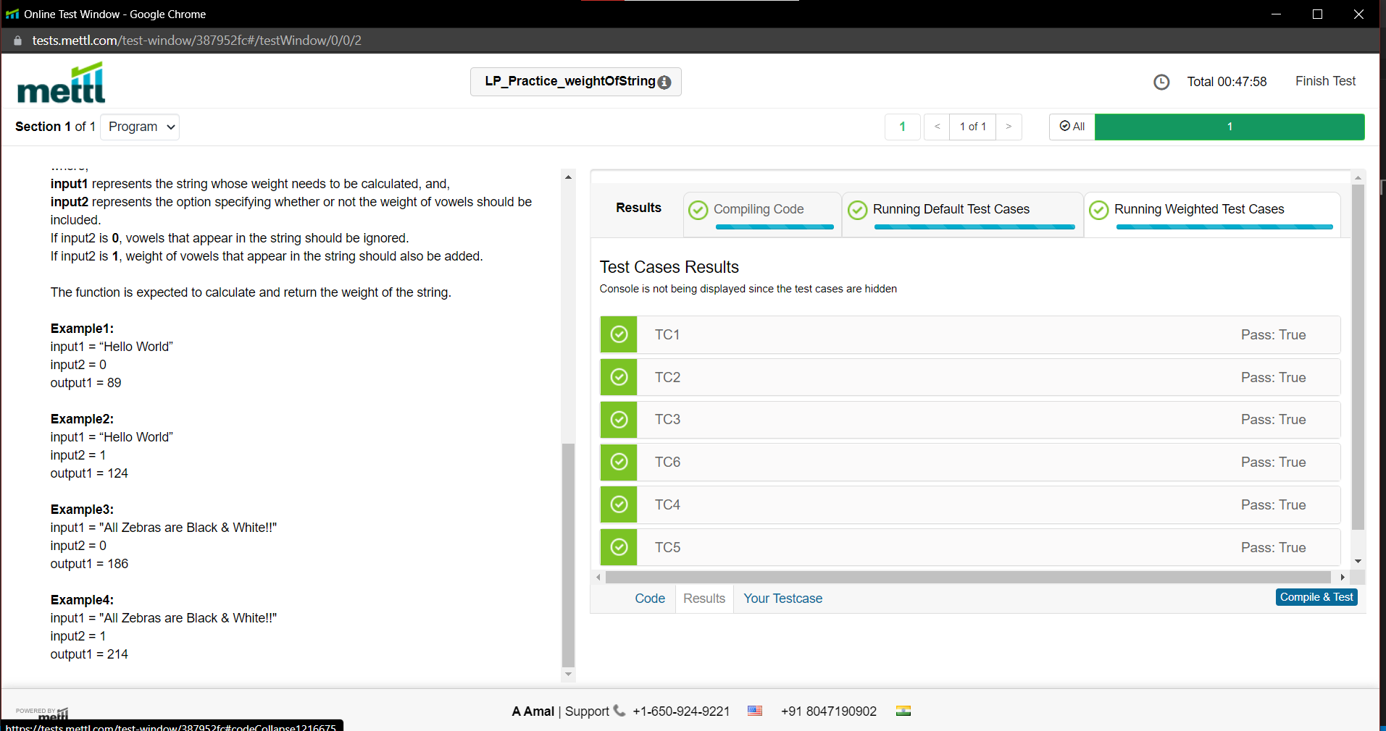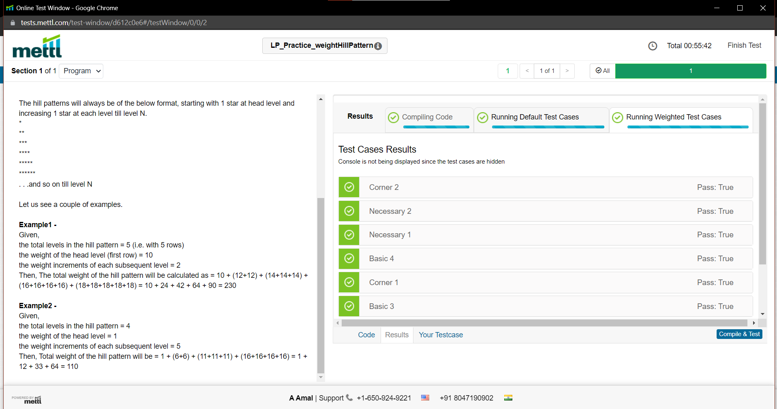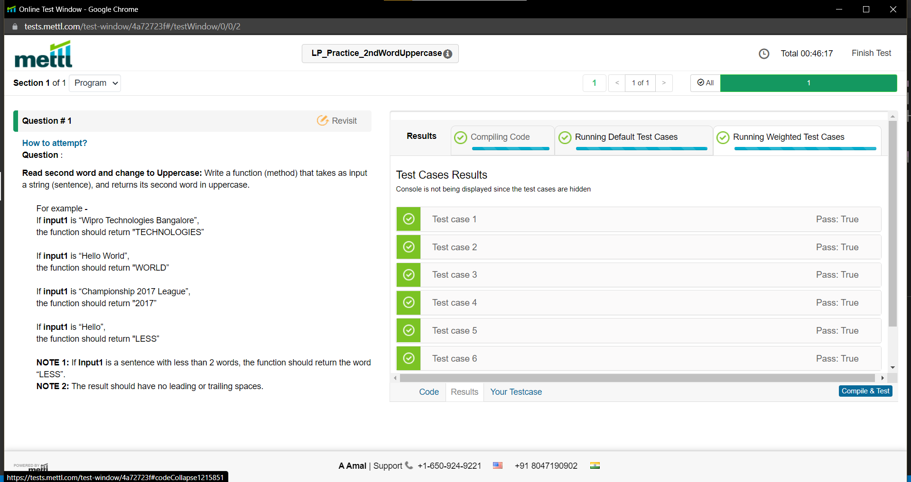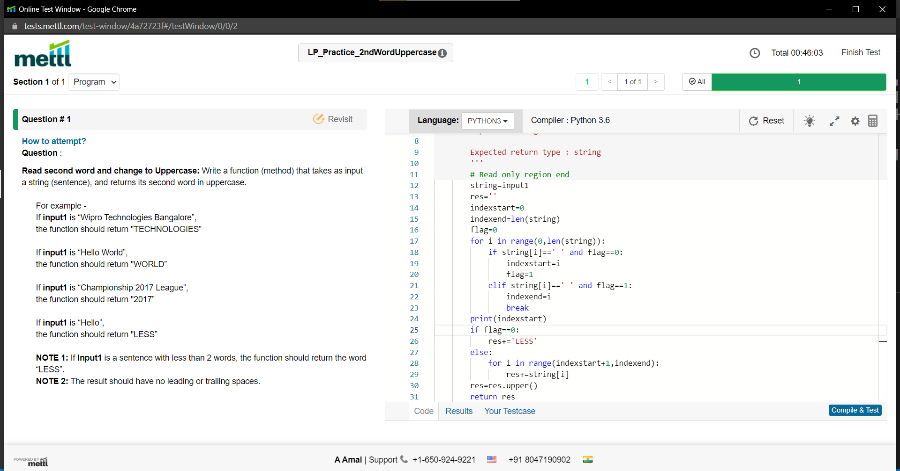

def shortername(name1,name2):

if len(name1)>len(name2):

return name2

elif len(name1)==len(name2):

for i in range(0,len(name1)):

if(name1[i]<name2[i]):

return name1

break

if(name2[i]<name1[i]):

return name2

break

else:

return name1

def longername(sname,name1,name2):

if(sname==name1):

return name2

else:

return name1

def finddigit(PIN,N):

pin='0'+str(PIN)

first_digit=pin[N]

N=len(str(PIN))-N

sec_digit=pin[N+1]

digits=first_digit+sec_digit

return str(digits)

input1='Kumud'

input2='Kumar'

input3=561327

input4=6

s_name=shortername(input1,input2)[-1]

l_name=longername(s_name,input1,input2)

number=finddigit(input3,input4)

uid=s_name.swapcase()+l_name.swapcase()+number

return uid

